**Annual Report of AmazingMartEU2**

**1. Profit Margin of the company State wise.**

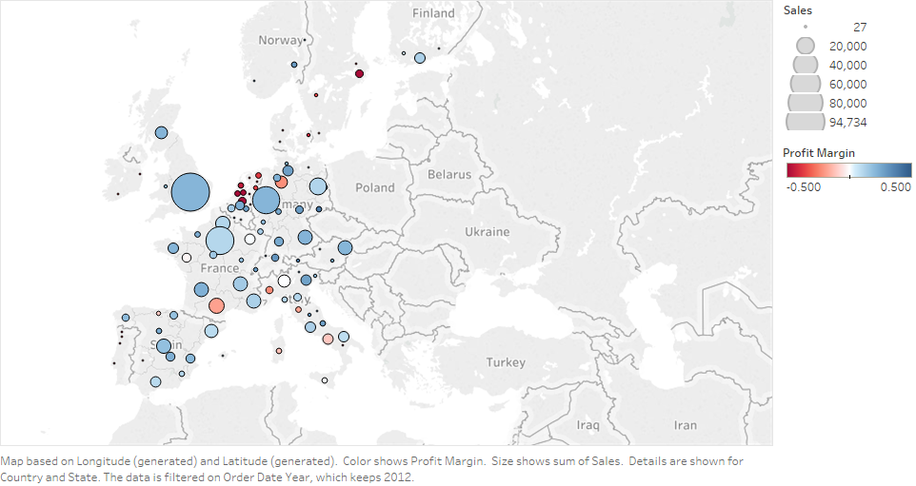

**2. Profit Margin of the company city wise.**

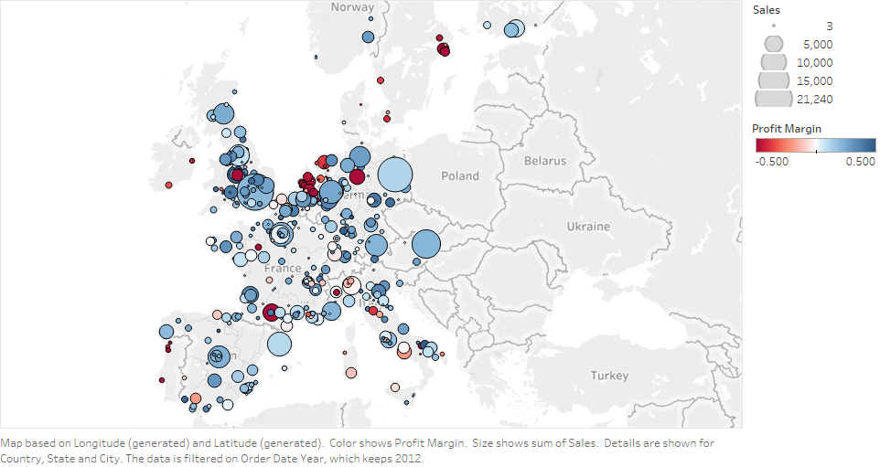

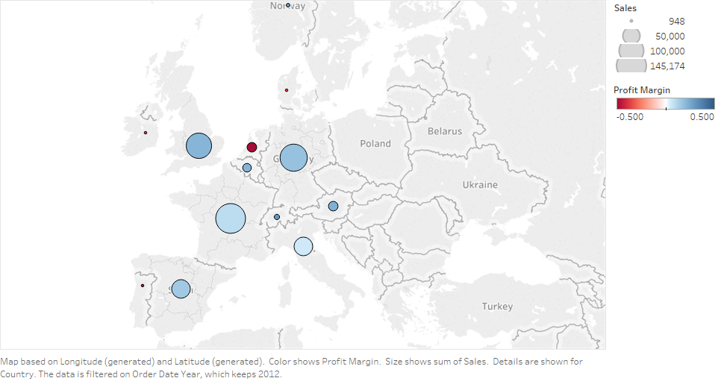**3. Profit Margin of the company city wise.**

**4. Profitability based on customer sales.**

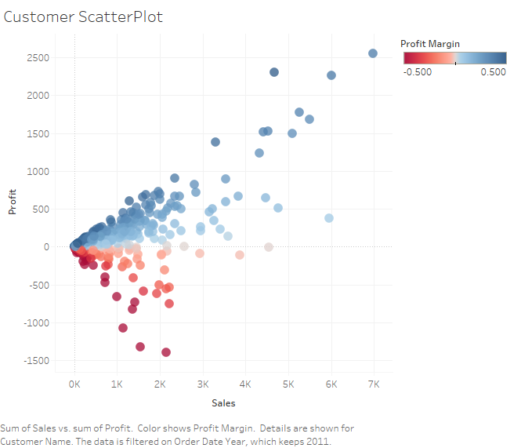

The top profitable customers should be enrolled in loyalty programs so that they can provide more profit.

Those customers are least profitable should be analyzed and checked that what is the reason behind it and should be provided more customer services or maybe they are buying wrong products.

**5. Comparison of the Sales and target of different departments.**

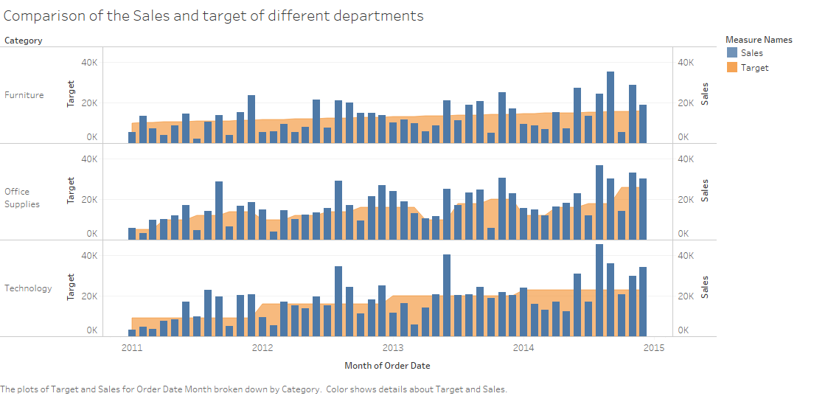

6. Excess Target Sales of Furniture’s Department.

There are many months where the department does not meet the sales target. Since the manager should change the strategy of setting the target of the sales.

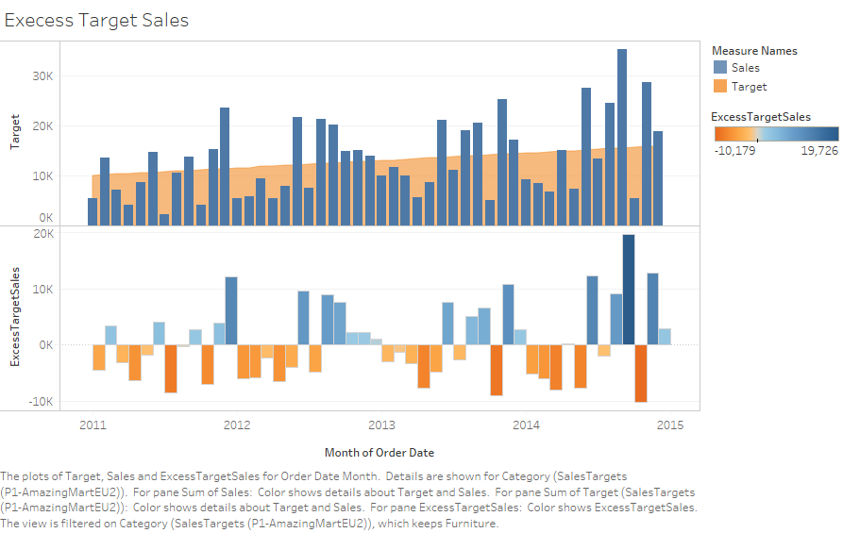

**7. Excess Target Sales of Office Supplies’ Department.**

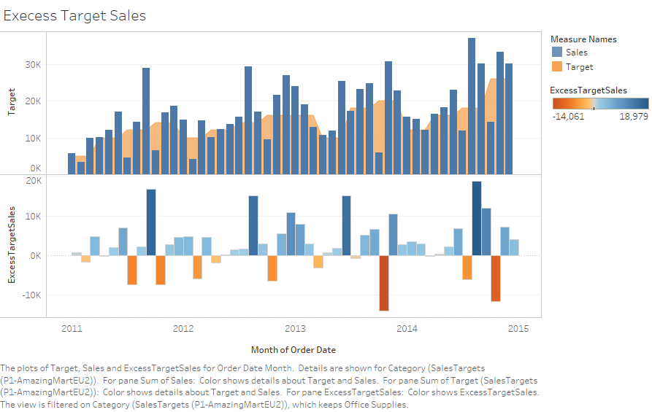There are very less months where they haven’t met the sales target as compared to other departments. The manager should tell other departments manager how they set the goals of their department.

**8. Excess Target Sales of Technology Department.**

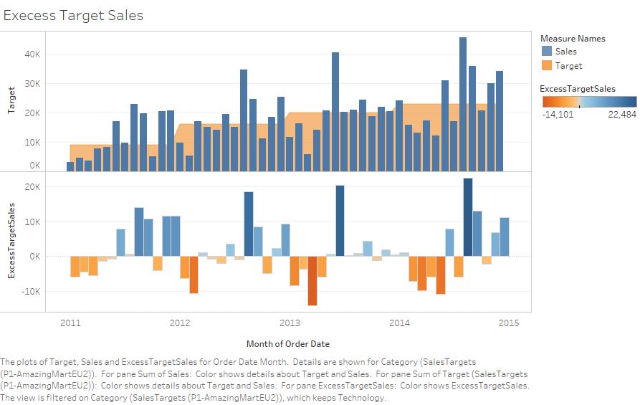The department set their goal for one year only. There is some seasonal factor they are not considering due to which they are unable to meet the target of sales. The department should consider the seasonal factors.